**Eclipse Reporting**

## Reporting

The reports are the end product of the Eclipse process and we have a strong library of available reports which will need to be customised to the specific mine, but the data integrity is built in from the database construction and the reporting uses standard software components.

* Out-of-the-box reporting
* Bespoke reporting
* Data exports : including Excel templates to get you started or to use out-of-the-box.
* PowerBI – including template to get your started.

### Out-of-the-box reporting

There are literally hundreds of different reports available in Eclipse. Choosing which ones you need consolidated into a single report on a daily basis is a matter of preference.

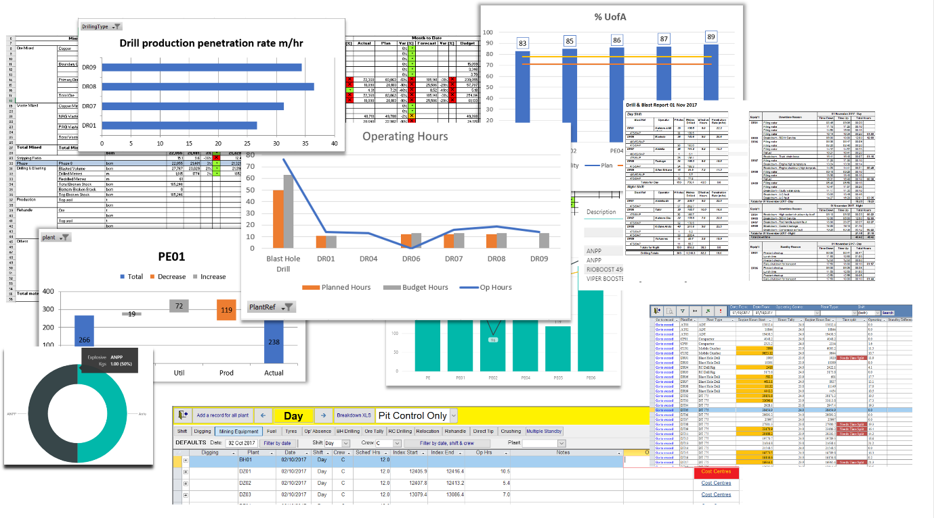

Date: 29th Aug 2018

# Table of Contents

Reporting 1

Out-of-the-box reporting 1

Geology Reporting 4

Microsoft Power BI 4

Contractor Costings 4

Bespoke Reports 5

Excel Exports 5

Live Dashboards 5

Sample Reports 7

Mining Daily Summary Report 8

CONFIDENTIAL 9

Daily Report part II 10

Downtime and delays report 12

Production v. EOM actuals 14

Dump Truck summary – Daily Summary 16

HME KPIs 17

Drill and Blast reports 19

Geology data entry sections 20

Ore Tally 20

Relocation 22

Rehandle 22

Microsoft Power BI 23

Contractor costs for all plant 29

Drilling costs 29

Other Costings 31

Explosives 34

## Types of Report

### Geology Reporting

Eclipse captures the movement of material for Geology from production through to processing and can import data relating to blocks and grades from different data sources. Queries and filters within Eclipse group and return reported data in lists which can, furthermore, be exported to Excel or linked to via Microsoft PowerBI. Additionally, Microsoft PowerBI can be linked to the live Geology queries.

Geology data entry sections

### Microsoft Power BI

Link to any of the Eclipse tables outputs or use one of our many preconfigured Power BI queries. PowerBI provides flexible tools for visualising the vast amount of data available in Eclipse to build knowledge and gain insights into your mine.



### Contractor Costings

Eclipse has various functionality relating to contractor costings which can be altered as per your requirements. Currently plant can be attributed to contractors and costs can be attributed to engine hours, consumables, drill productivity and explosives. Reports within Eclipse can be generated and grouped as well as exported to Excel or linked to using Power BI.

* Contractor costs for all plant
* Drilling costs
* Other Costings

### Bespoke Reports

Use the bespoke reporting tools in Eclipse to create your own queries which can be saved and added to your own report collection. Column settings can be saved and results exported to Excel for further analysis.

### Excel Exports

|  |  |
| --- | --- |
|  |  |
| Live Dashboards |  |
|  |  |
|  |  |

## Sample Reports

There are thousands of different ways in which the reports can be queries and then viewed, exported, emailed and printed from Eclipse. Which ones you want to see on a regular basis are a matter of personal choice and we can help customise report packs for you.

### Mining Daily Summary Report

The report on the next page is The Mining Daily Summary Report and at the heart of the daily meetings.

It summarises everything that day, week, month year to date and compares it against targets; plans, forecasts, and budgets. This is primarily production colour coded to highlight the areas out of target range. Production figures and comparisons with targets. This report shows day, WTD, MTD and YTD (all pits) but can be customised to your requirements e.g. by shift and pit.

* Colour coded
* Fits onto a sheet of A4
* Exported to an Excel spreadsheet so that your engineers can access data without requiring programming skills and use a tool which they’re comfortable with.
* Stored as a static file independent of the dynamic Eclipse data.
* Material types ordered according to those specified by you in the setup screens.

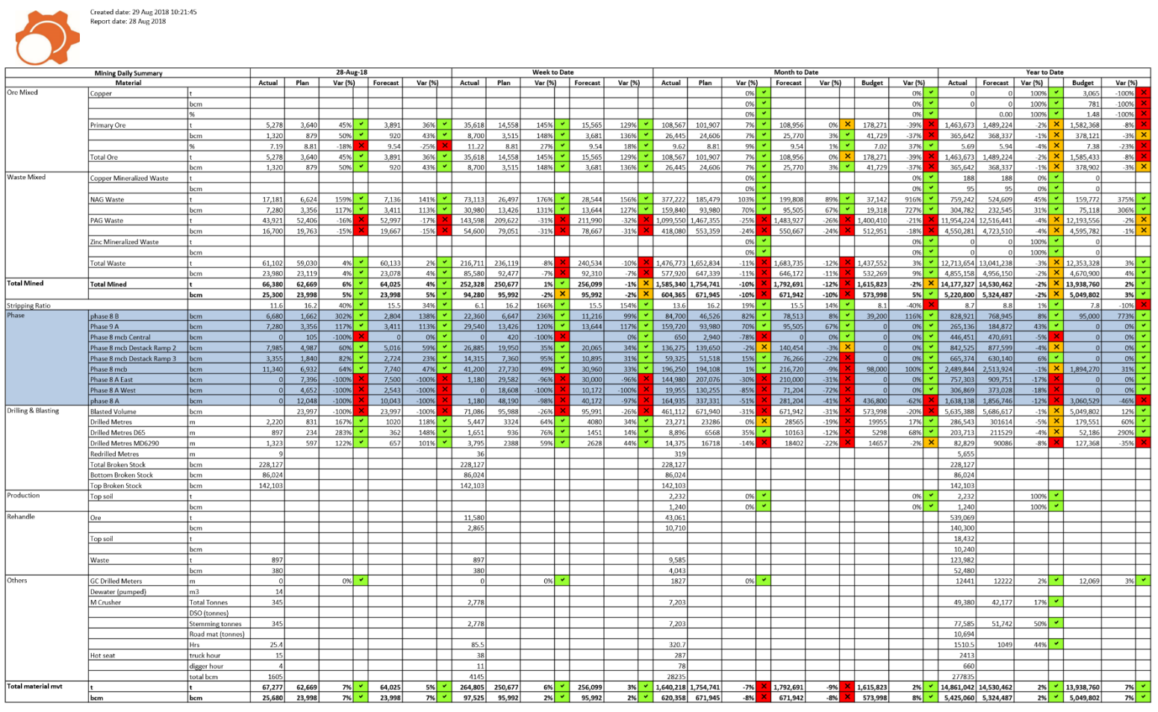

### CONFIDENTIAL

### Daily Report part II

The report on the next page is an Equipment summary. These charts show how the output figures (in the chart above) were achieved, broken down to specific pieces of equipment so management can track any issues or problems/ bottlenecks.

Productivity, Availability & Utilization and other key pieces of information in a single report with A4 width.

* Colour coded
* Split by shift, day, WTD, MTD, YTD
* Compared with targets
* Ordered by plant types as specified in the setup screens

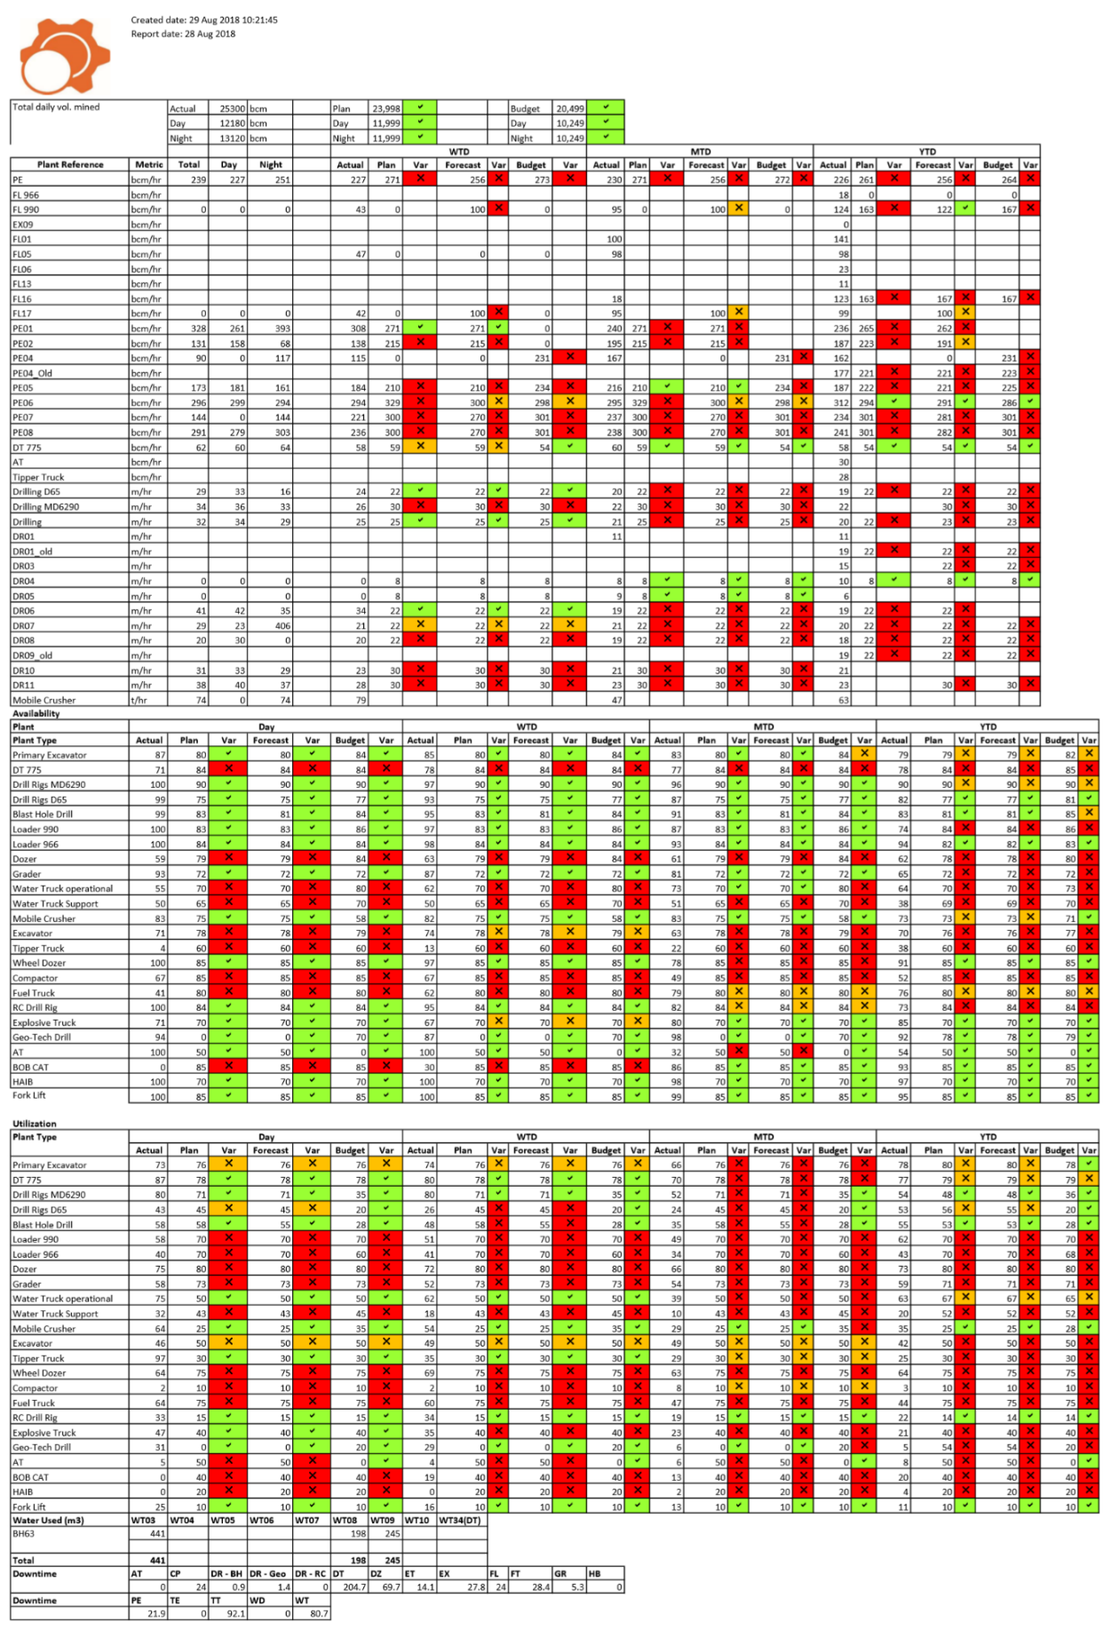

SAMPLE

### Downtime and delays report

The next page shows how the equipment performance can be further be identified by specific causes – breakdowns, delays etc.

Specifically, downtime and Non Operational Delays for selected plant types, split into shift.

* Can be printed onto A4
* Saved as Excel document
* Ordered by plant types as specified in the reference screens

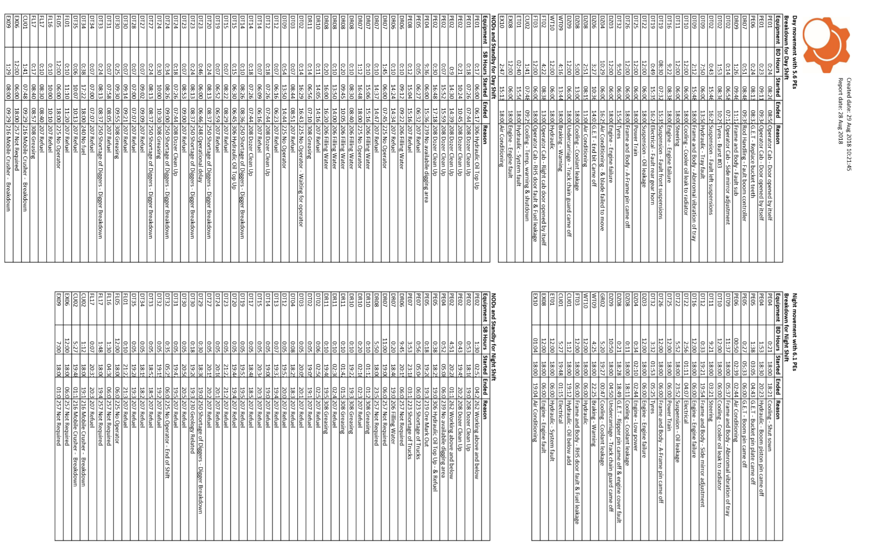

SAMPLE

### Production v. EOM actuals

It is important to build in a feedback loop to ensure that the factors used in the daily production calculations used by Eclipse are tested against the actual production at the processing plant (for example). This must be a standard part of the management procedure.

At the beginning of each month, the previous month’s production figures are backed-up for quick and easy comparisons with the EOM Actuals. This report is an example of how the information can be reported.

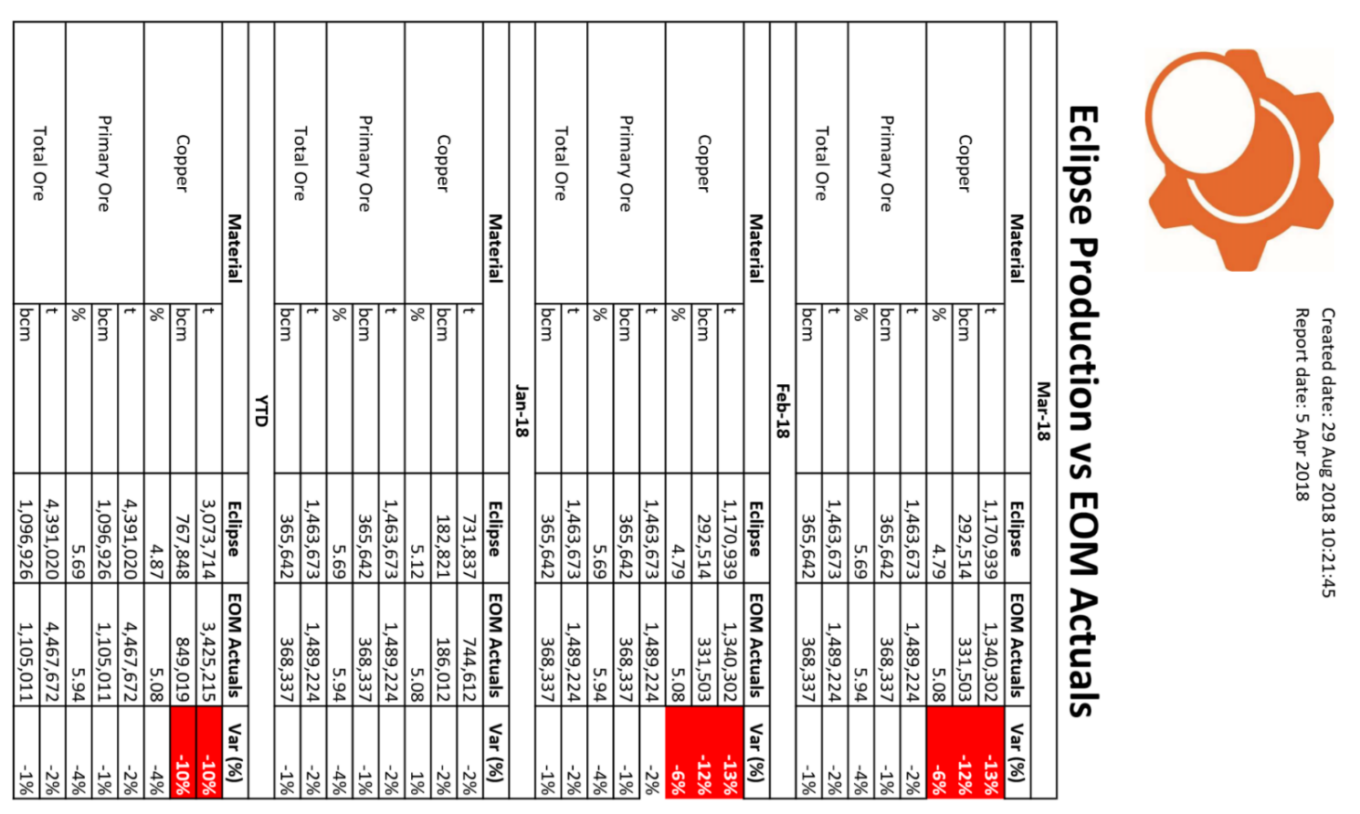

SAMPLE

### Dump Truck summary – Daily Summary

Usually this report is e-mailed to senior staff at the end of end shift.   
Shows the loads for each hour by truck, loader and material. A similar report exists for relocation.

This report is typical of the summary page supplied by pit control which should be reviewed by staff.

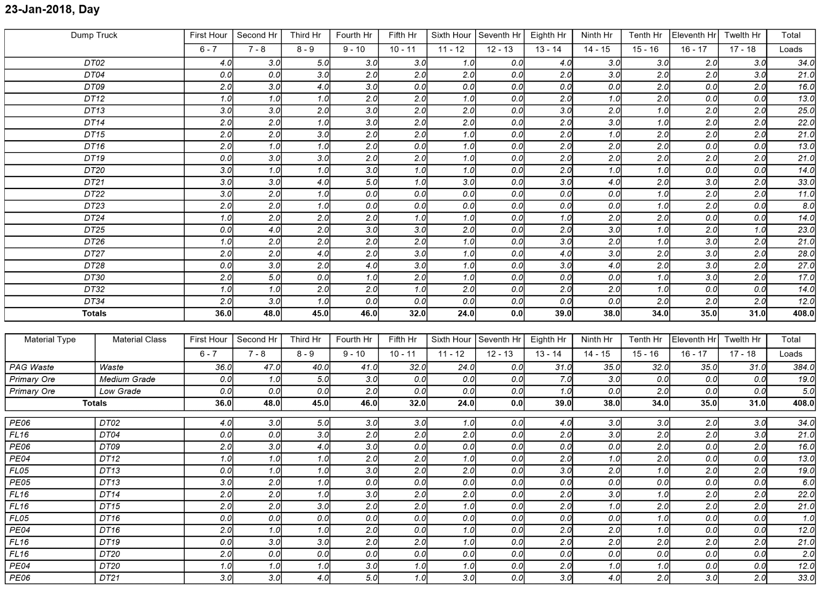

SAMPLE

### HME KPIs

Heavy Mechanical Equipment – Key Performance Index.   
Monthly summary on availability and utilisation of equipment.   
Operating hours, availability and utilization by month and YTD, ordered by Plant Type as specified in the reference screens. Colour coded ticks and crosses relating to targets.

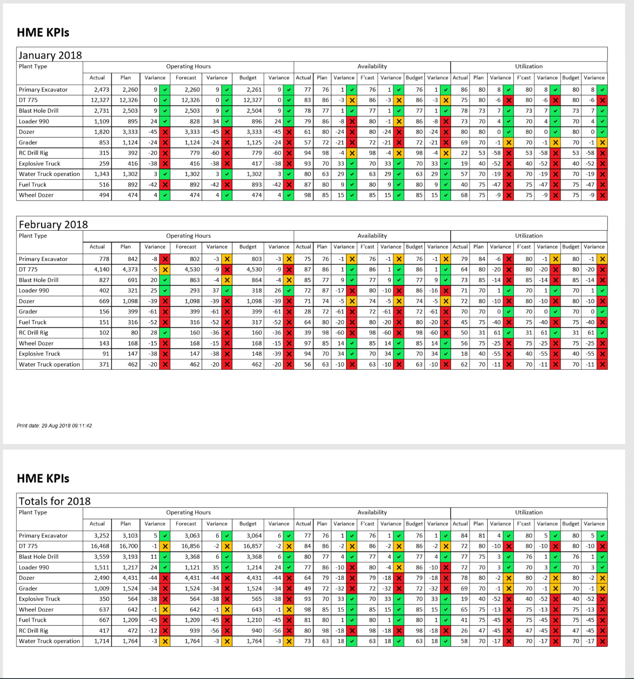

SAMPLE

### Drill and Blast reports

This is a comprehensive record of all the blasts. Location, depth, process etc.  
Separately we can also track explosive stocks, and measurements of the ‘success’ of the blast.

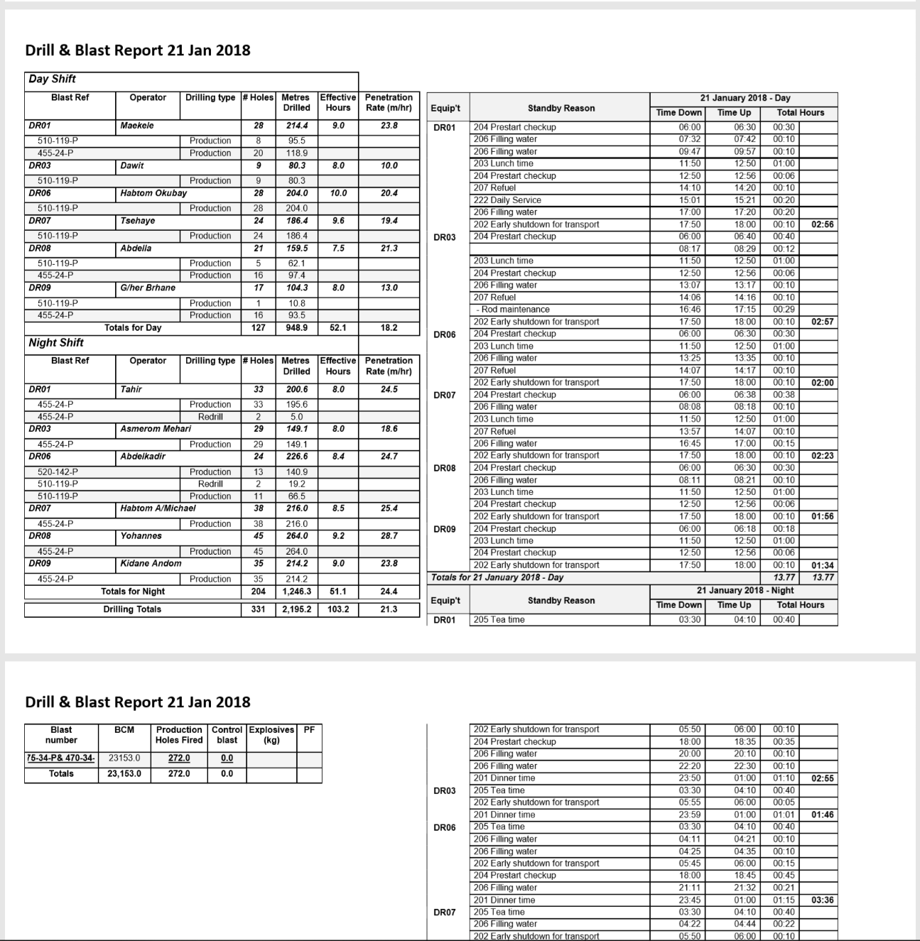

SAMPLE

### Geology data entry sections

Movement of material is recorded through the Geology sections enabling stockpiles balances, grades and densities to be updated on a daily basis.

Operating/Cost centres can be identified from the PLOD sheets and/or automatically identified by Eclipse. For example; DT06 may be working in production, rehandle and relocation in a single shift.

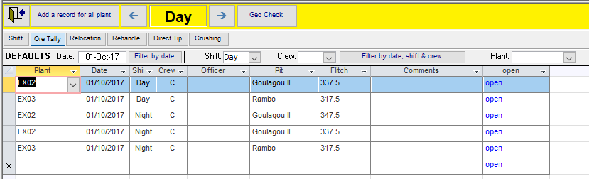

### Ore Tally

Geology have a separate cataloguing system for the measurement of ore movements and Eclipse compares their spotters’ reports and Eclipse facilitated the cross check the measurements

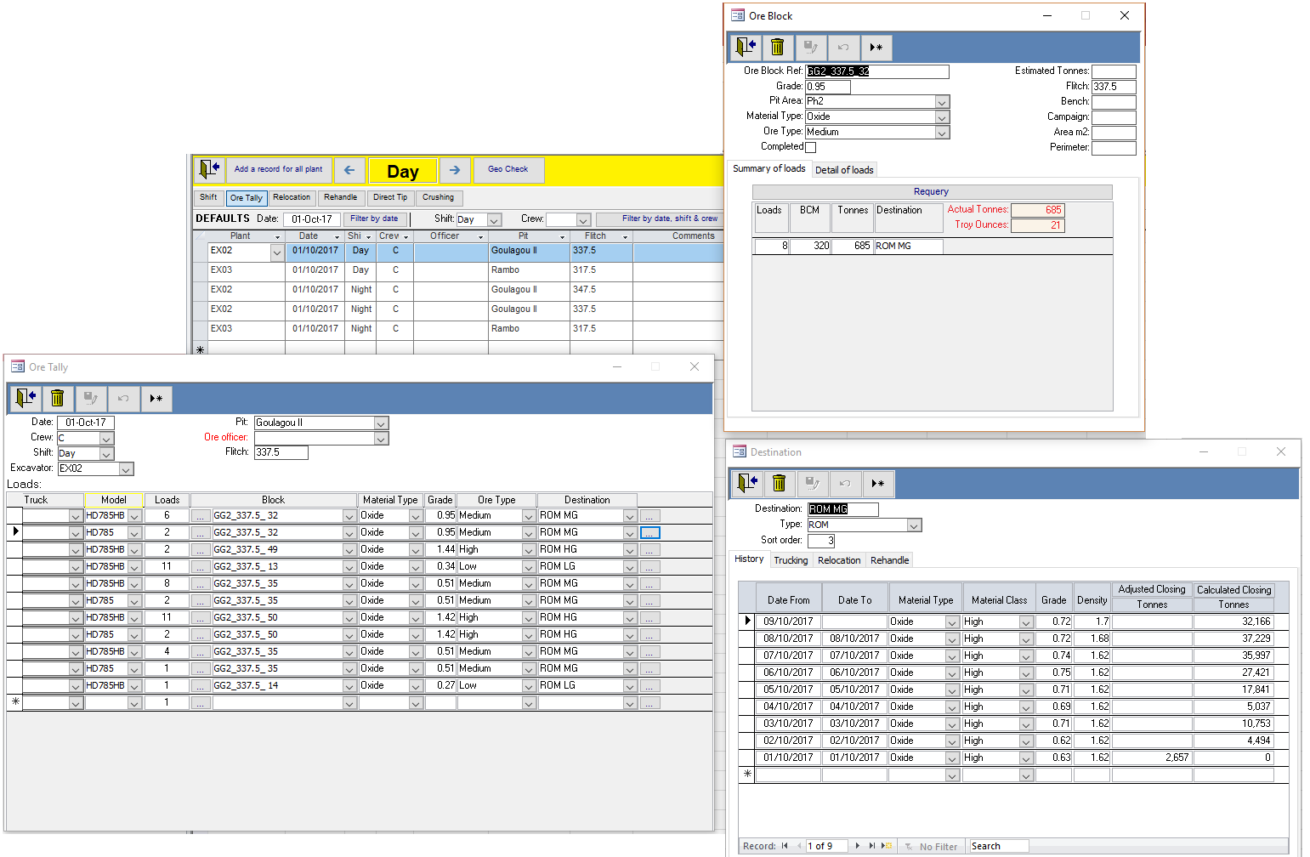

SAMPLE

The integrity of the data is maintained through Ore Blocks, Plant Models and/or individual Plant and destinations (ROM).

### Relocation

Stockpile balances are recalculated at the beginning of a new day and can be manually overwritten. Material moved from stockpiles uses the material type, densities and grade for that date.

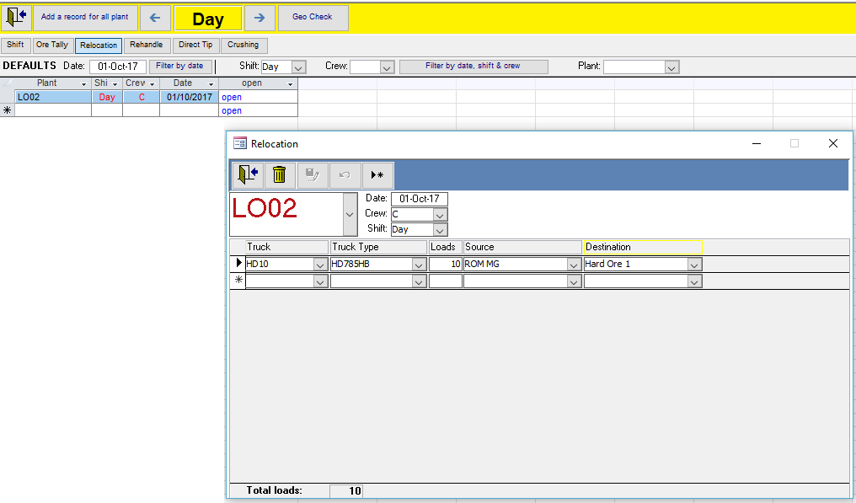

SAMPLE

### Rehandle

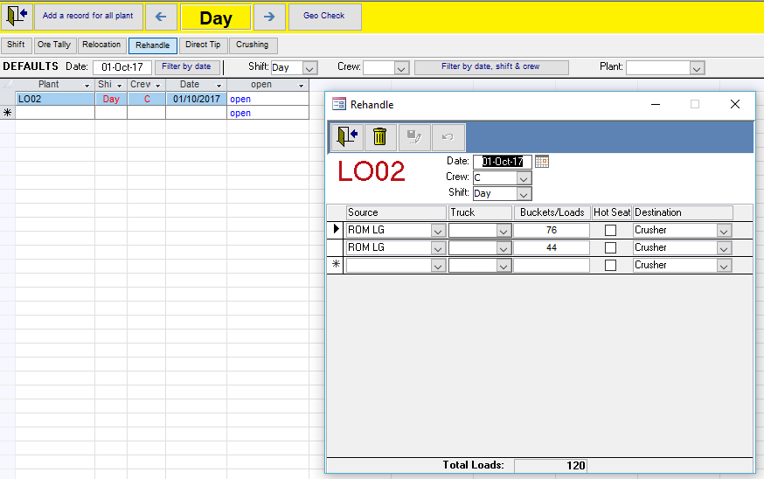

Factors used depend on whether the loaders are loading directly into a crusher or using trucks.

### Microsoft Power BI

PowerBI is a powerful new tool available for presenting complex data in graphically helpful ways.

* The graphics illustrated below can be uses with very little training, to drill down from top level information, into detailed and actionable data.
* It is also available via small screens and away from site, so is perfect for managers that are on the move.

Link to any of the Eclipse tables outputs or use one of our many preconfigured PowerBI queries. PowerBI provides flexible tools for visualising the vast amount of data available in Eclipse to build knowledge and gain insights into your mine.

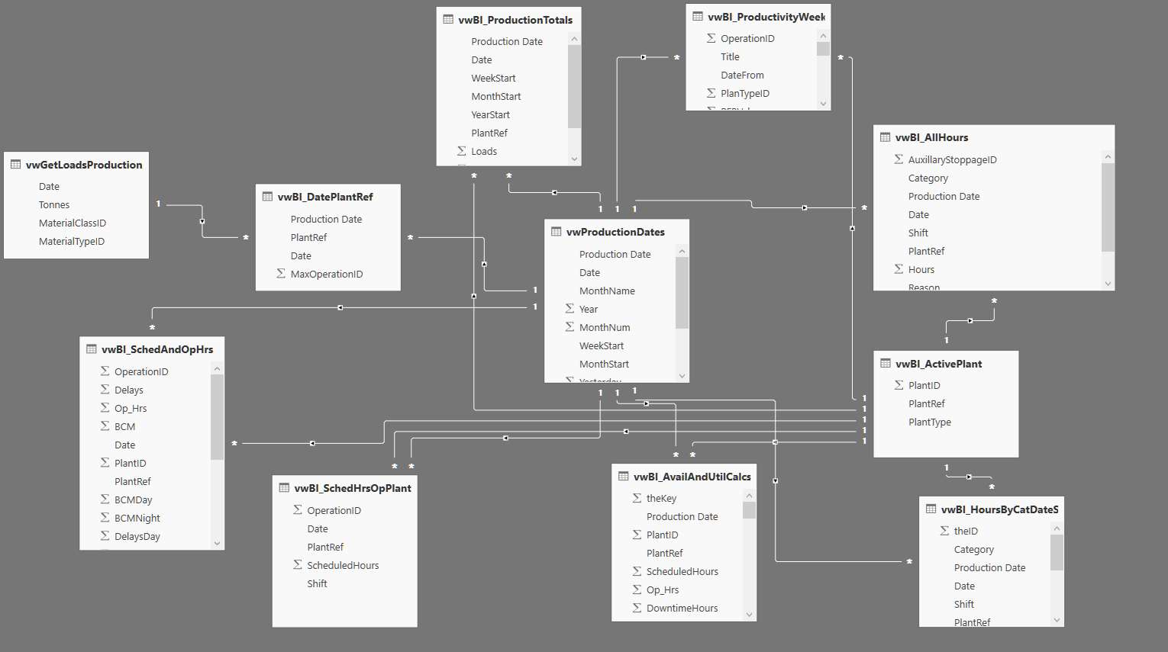

SAMPLE

A small selection of standard Eclipse PowerBI visualisations are displayed below.

PowerBI reports are available

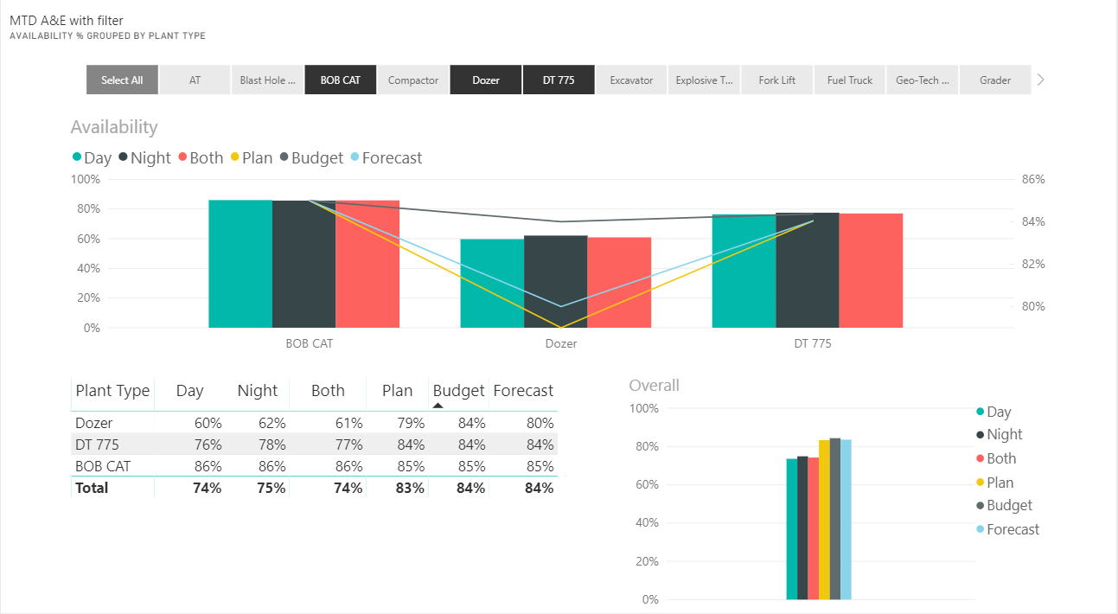

SAMPLE

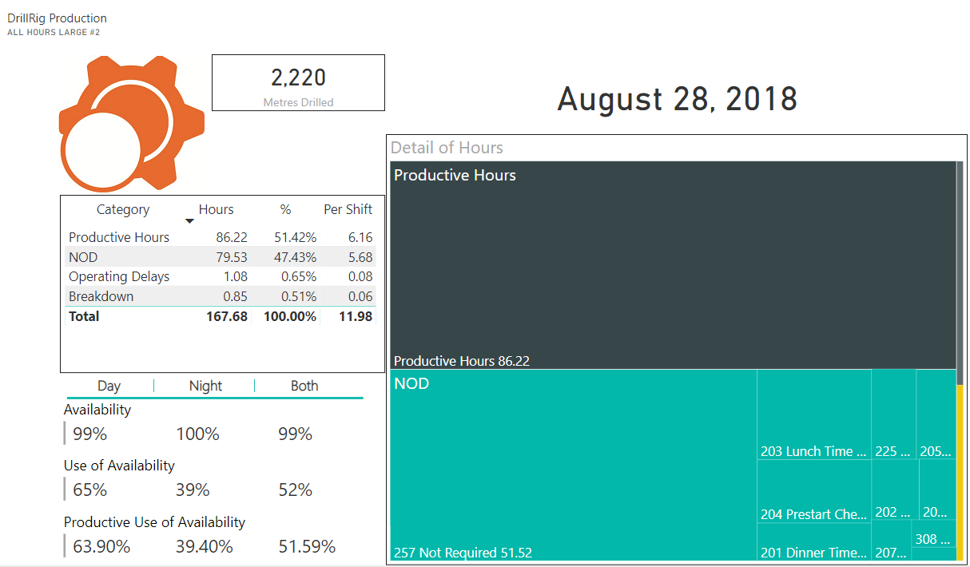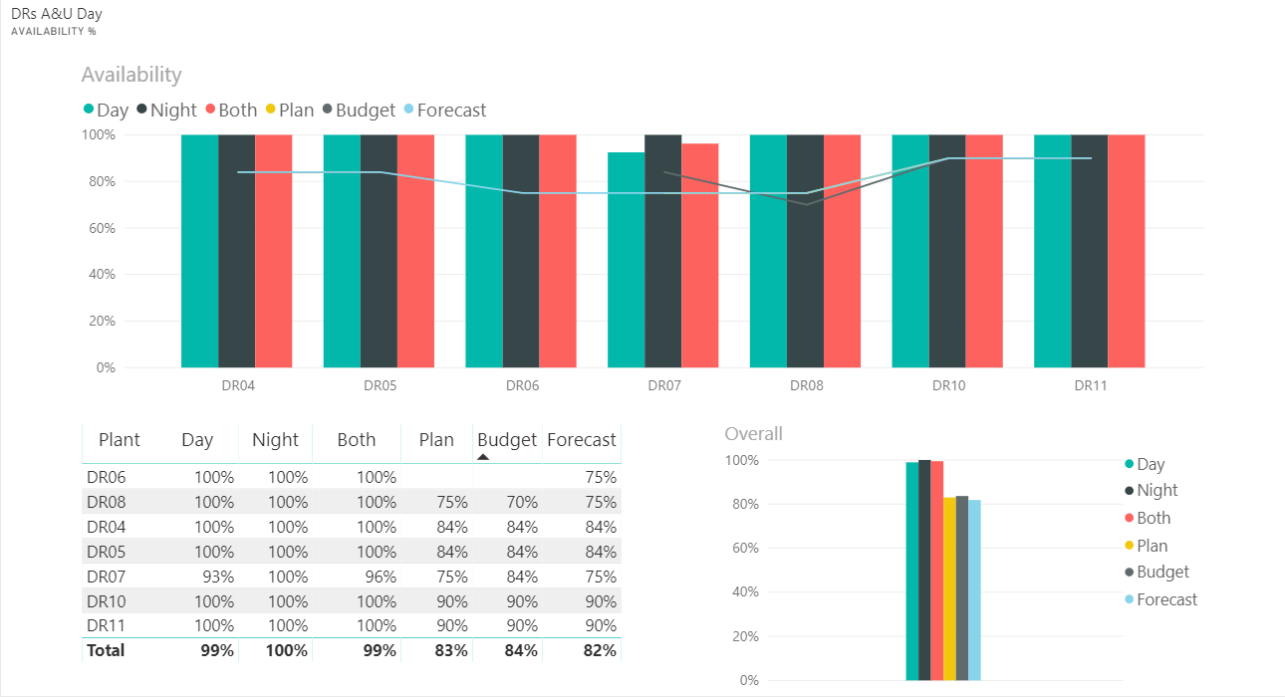

SAMPLE

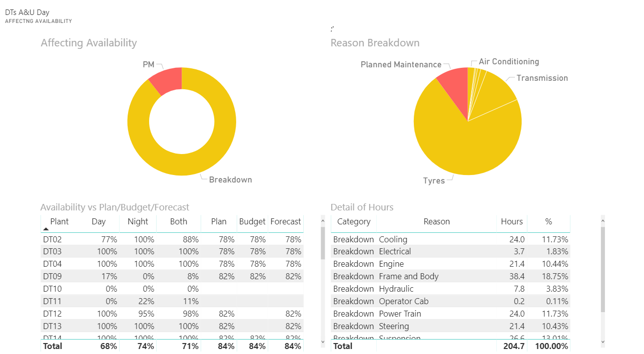

SAMPLE

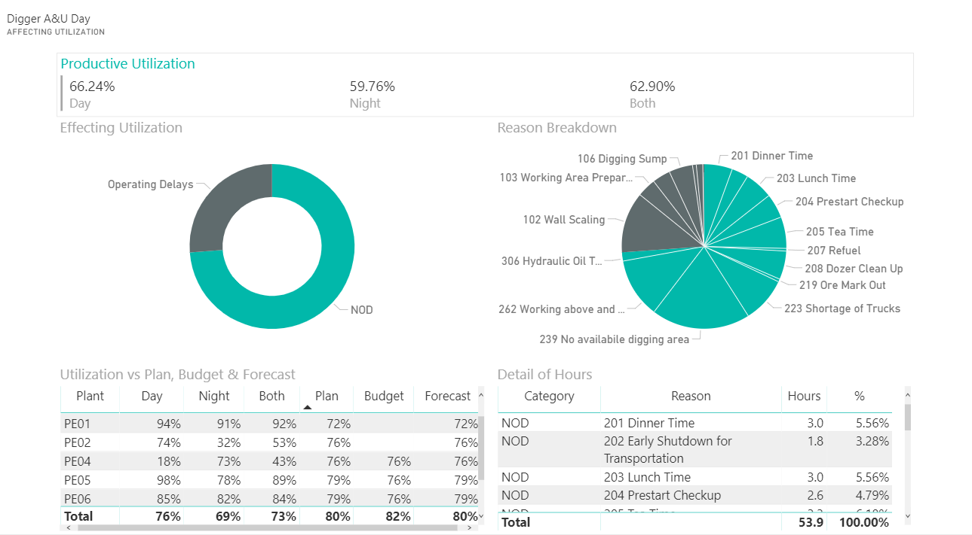

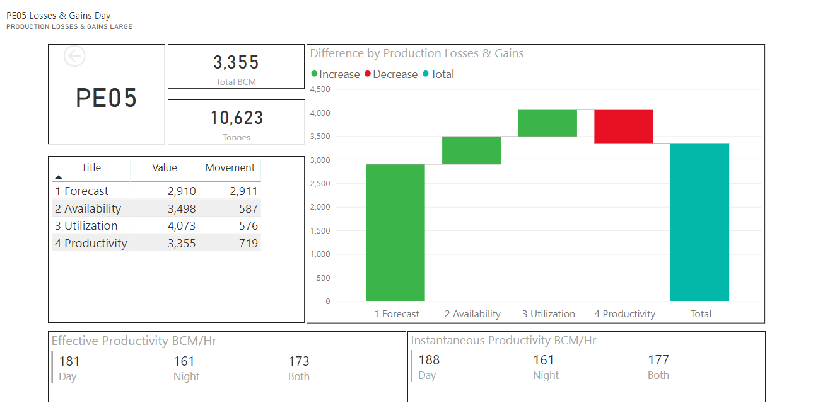

Contractors

Contractor costs and can be tracked and reported on using Eclipse.

### Contractor costs for all plant

*Automatically calculated and grouped based on date range and data entered via Plod sheets or imported contractor detail*

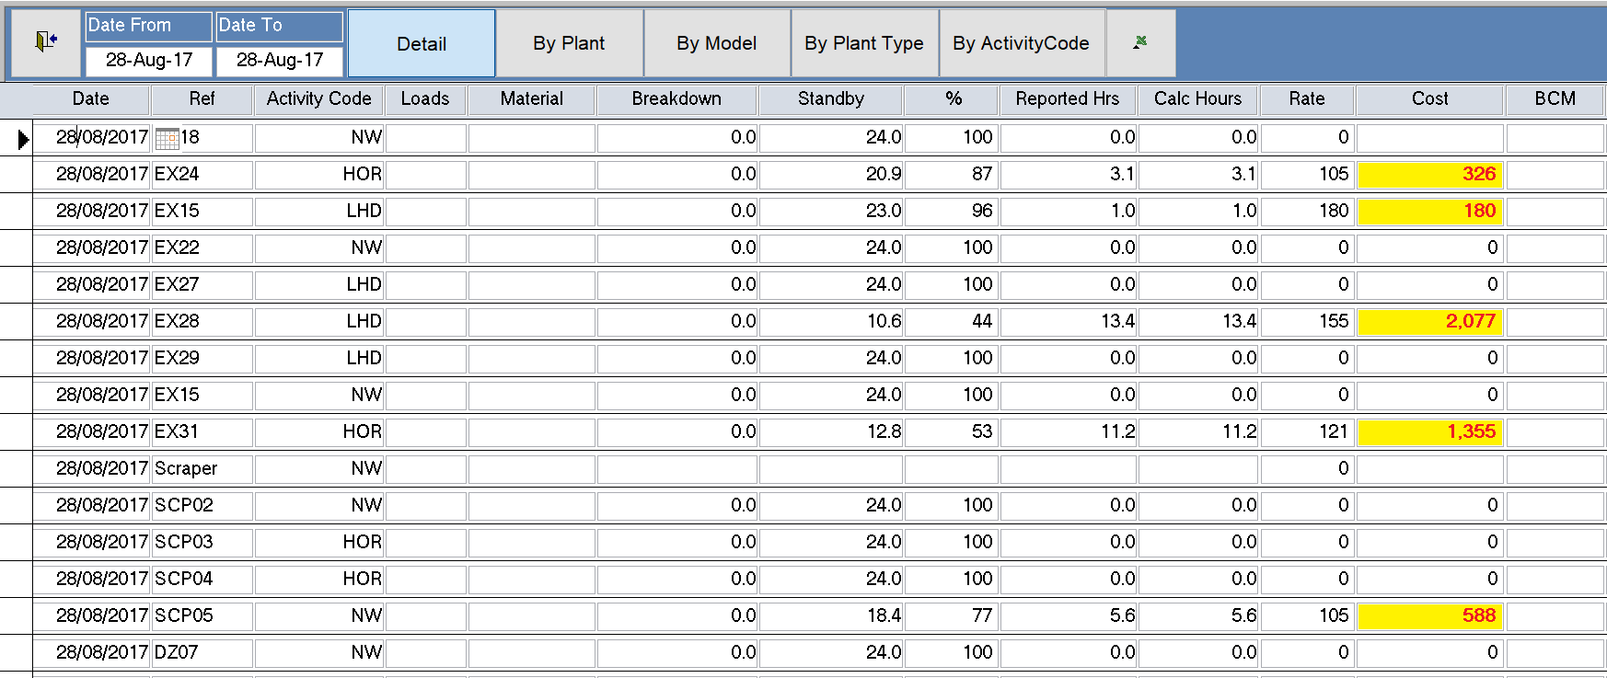*.*

SAMPLE

### Drilling costs

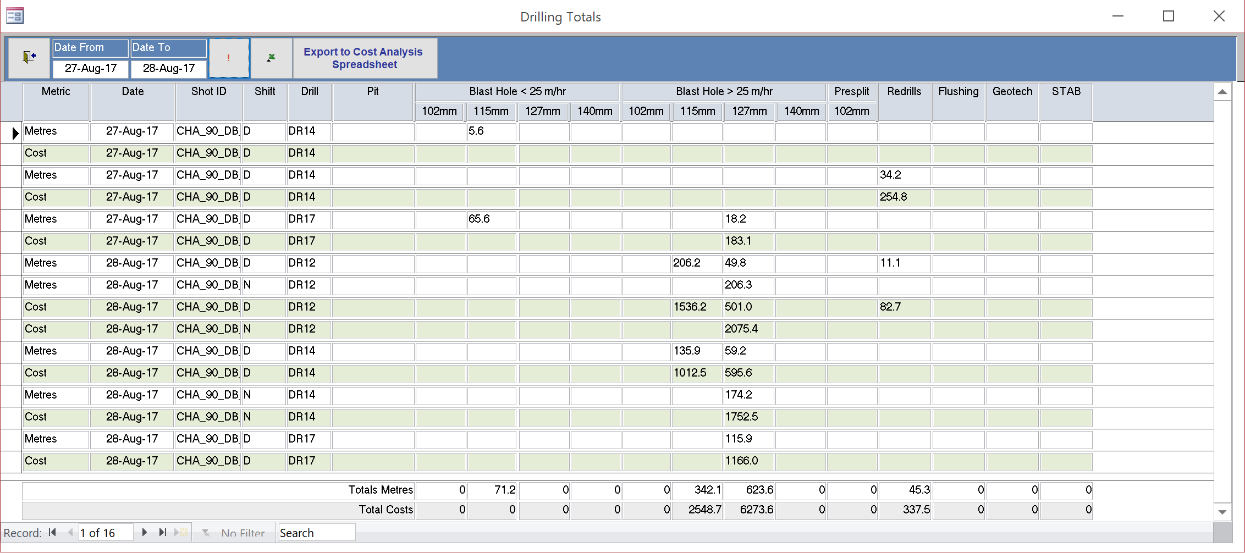

*Drilling costs can be calculated based on metres drilled, penetration rate and drill bits used. Based on data entered via Plod sheets of imported from contractors.*

### Other Costings

Keep track of drilling consumables through the Eclipse inventory system. Report on costings and gain insights into your consumables using PowerBI and the Eclipse queries.

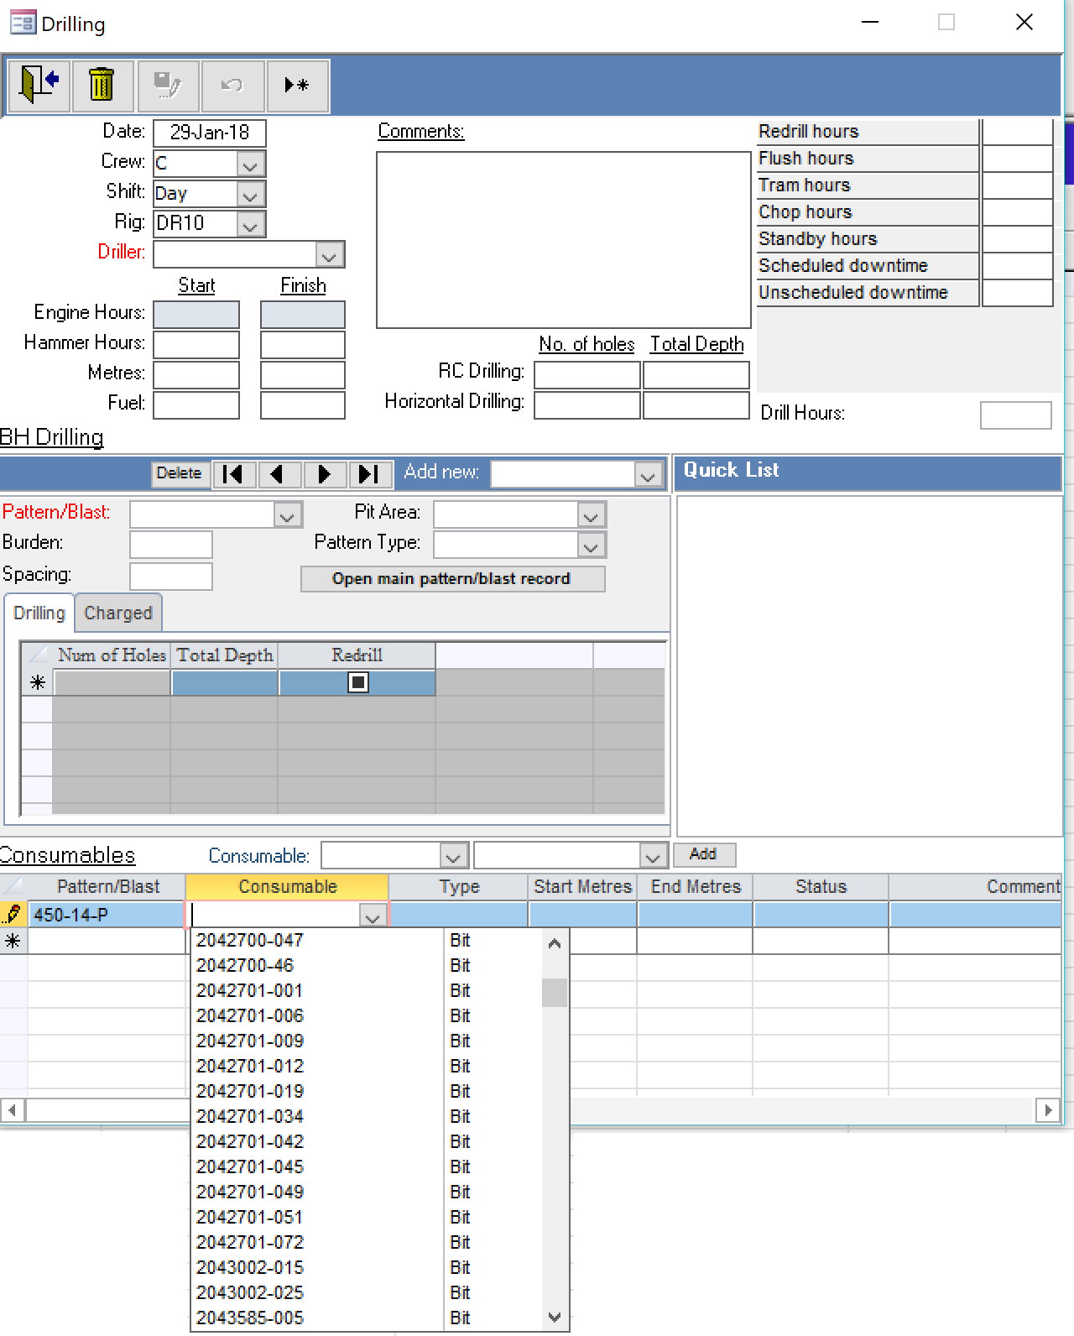

SAMPLE

### Explosives

Use Eclipse as your explosives inventory, track costs and compare designs with actuals.

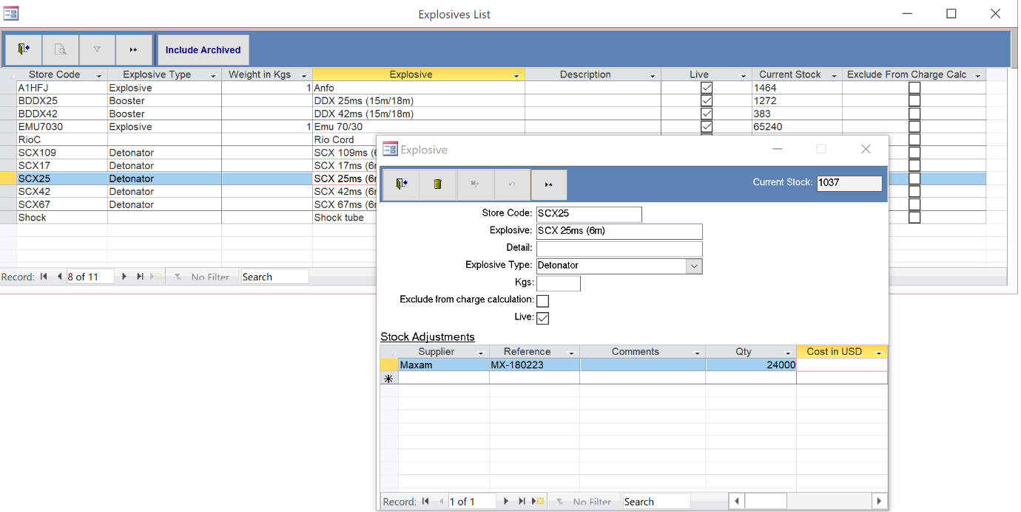

SAMPLE