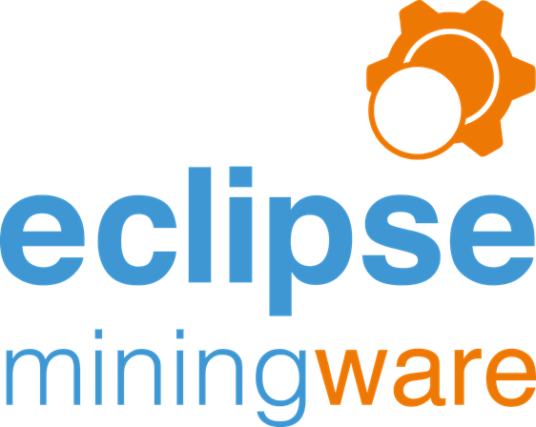

Prepared by:
Stephen Milton BSc ARCS MBA Stephen.Milton@thedevteam.co.uk
Nigel Taylor BSc nigel.taylor@thedevteam.co.uk

Version: 1.3
Date: Nov 2018

Table of Contents
Eclipse Miningware 1
About Us 1
Key Staff 1
How we work Work 2
Typical Work Plan and Schedule 4
Indicative cost breakdown 5
Relevant Experience and Client References 6
References 6
Core Team 6
About Eclipse Miningware 7
Summary 8
Eclipse Miningware Modules 9
Eclipse Mobile data entry 10
Eclipse Web Plod Synchronisation 11
Eclipse Web Plod to HME 12
Production 13
Pit Control 13
Drill & Blast 13
Engineers 14
Geology 14
HME 15
Collaboration 16
IT infrastructure requirements 16
Off-Site Training and Documentation 16
Project Management 16
Licensing 16
6 Monthly Review 17
On-going Support and Development 18
Deployment Plan 18

Eclipse Miningware
Eclipse Miningware has been specifically developed to provide you with a cost-effective solution for accurately tracking and reporting on your mine’s production, comparing with targets and enabling you to make informed decisions which will help improve productivity and reduce costs.
Our solutions are built on solid, tried and tested foundations, designed to save you and your staff time with accurate and timely outputs. The major mining companies that we have worked with in developing this platform are Newcrest, Newmont, Endeavor, Nevsun Resources and others.
When you purchase a software license from us you are not only purchasing the right to use our software but you are buying our support services, access to our software development team, the Eclipse knowledge base, and training. We are here to take the pain out of data collection and validation.
- Easy data entry
- Validated and accurate information
- Real time reporting
- Access to the entire database history

About Us
The Eclipse Miningware has been created by a dedicated team of software engineers who have been working together for over 15 years.
We specialise in large database collaboration tools that overcome the inherent weaknesses of spreadsheet management by creating coherent and professional data capture and reporting systems. Producing reliable and consistent results that have the capacity to transform the management of a business.
In addition to multiple mining installations, we have implemented systems for managing the documentation of large constructions projects; documenting over £1.5bn of projects for some of the most prestigious and demanding clients in the world, as well as major ecommerce systems. We are adept at working in the fast moving world of software development which requires continuous updating of software to avoid the legacy trap of tools that have become out of date.
Having built all the software from scratch using standard Microsoft tools, we are able to make quick modifications to tailor everything to each customer’s needs, building on the solid, tried and tested foundations of previous installations.

Key Staff
Stephen Milton BSC ARCS MBA
Group MD and project manager
+44 1424 423827 (DD)
Nigel Taylor BSc
Director and chief software developer
+44 1424 869327 (DD)
Innovation Centre,
Highfield Drive,
Churchfields,
St Leonards-on-Sea,
East Sussex,
TN38 9UH
UK

Other staff involved

David Radley - database software specialist for HTML reporting systems
+44 1424 869326 (DD)

Joe Shaw – software engineer and specialist in Chrome/ Android form handling
+44 1424 442400 (Main Office)

Assisted by the rest of the team as needed.

Eclipse Miningware created by TheDevTeam, part of the Denaploy group of Companies

How we work Work

To see how Eclipse works in practice see the attached selection of reports from the standard library of reports within the Eclipse system as a separate document.
We would welcome the opportunity to present to the management team so that we can demonstrate the ease of data entry as well as its robust structure in handling human error. Our experience in working in some of the wilder regions of Africa has made it necessary for us to refine the data entry system to be very user tolerant.

Some specific issues :
- Simple and reliable data entry can be undertaken form a variety of different sources. Automatically as a feed from suitably equipped equipment (such as trucks that provide automatic load and movement data), or from ‘spotters’ filling in the movement data directly into the database. We have also developed “Standard Time Plod”. If we can get the operators to enter the times directly into a web app from their vehicle whilst they’re on their shift then we would then have ‘real time reporting’, greater accuracy, and more data without needing more than 1 data entry person. Less time would also be required for “Data Support – Geologist” and the “Mining Engineer” thanks to the in-built validation.
- Create an in-built data management protocol: e.g. We can design the data entry screens so they are related to date + shift and are colour coded for example + all plant currently active is automatically becomes available at the beginning of each shift
- There is considerable data validation in the Eclipse software which is best demonstrated with a live run through. Validation overlays which are corrected for reporting purposes.
- Note that the project management needed to achieve a change in procedures across the whole mine, requires senior management report.
- Reporting
  - EOM Actuals can be entered for production and other metrics required by the Mine (see below) enabling comparisons between actuals and data entered into Eclipse. Additionally, YTD production and even targets can take actuals into account depending on the mine’s setup e.g. The mine may calculate YTD Plan as the actuals up to the end of the last quarter and the monthly plans from that point onwards. Eclipse has been designed to be flexible in this respect.
  - Material movements for geology – Ore waste to rom, concentrator etc.
  - Reports for contract management (explosives + drill bits)
  - Contractor reports – blast hole loading
  - EOM Actuals for a month are automatically created when the daily reports are created for the first day of a new month. Staff will then overwrite the automated figures and mark them as “reconciled”. These figures are then used to calculated YTD and even quarterly or YTD targets where specified. The unreconciled figures and subsequent reconciled figures give Eclipse users the opportunity to compare ‘actuals’ with figures entered into Eclipse and adjust business practises accordingly.
- Eclipse has many import functions due to the fact that each department tends to have their own preferred methods of recording information, particularly when considering targets. For example; the HME department may have an Excel spreadsheet for setting utilization and availability targets on plant which is completely separate to Eclipse. That department may have different targets on a day to day basis whereas a different mine may record targets for a month. As a group of programmers, we are used to dealing with many different systems which include databases, JSON services, CSV files, Excel files and more. Each set of import routines would be bespoke and require some level of setup, user interaction (to match plant for example) and data validation.
- Each set of Excel Reports is exported and saved to a separate file with standardised naming conventions i.e. Excel Workbook name + Windows username + date range.
- Alternative reports. Can also be exported in raw format to Excel.

Acceptance testing
Acceptance testing normally is built around a comparison of existing reports against those generated by Eclipse as it goes live. In our experience, this is frequently about convincing people that there are flaws in the existing systems of which they were unaware and requires a strong manager to act as arbiter in the event of an unresolved conflict. This activity can also bring to the fore subtle differences between the understanding of different departments.
Normally we would have included a resource for handling this as part of the change management requirements, but we have been assured that this will be handled by the company and that we will only need to offer the technical support necessary to enable it.

Once Eclipse is live we encourage user acceptance by implementing Beta versions of the target applications (when changes are made to mission critical functionality). Once signed-off and accepted by staff, the changes are made live. TheDevTeam follows strict version control procedures and plan upgrades at times convenient to the client.

Knowledge Transfer
Our best customers are the most well informed. We are happy to enable customers to manage the system development to the limit of their competence working with in house software developers if available.
It is very important that at least one person on site can be considered an expert user to handle all the routine questions that will arise each time a new user is introduced to the system.

The standard version of Eclipse includes a “test” version so that users can familiarise themselves with the functionality without compromising the integrity of the live data. This is especially useful for Admin staff who are new and unfamiliar with a system that has such a broad range of functionality and data which is shared across departments (e.g. Geology and Production).

Typical Work Plan and Schedule
In the event of us being awarded a new contract we would expect to
- Immediately start preparatory work to customise the software to the specification supplied
- 1st Oct – begin a 2 week visit to site
  - to install software on the local network and provide training for all key members of staff.
  - There is a degree of ‘change management’ that will need to be put in place during that 2 weeks and we will need the full support of senior section heads and the Mining management team in undertaking these changes and forcing them through.
  - Input ‘historic data’ from the beginning of the Budget period so there are meaningful comparisons, and Budget and Forecast numbers.
  - By the end of the visit we expect the system to be up and running and be the main vehicle for the daily meeting and other review processes.
- Remote support for 2 months
  - During the following 2 months after installation, we will maintain a remote detailed review of the system to check that no systematic data entry errors are being made
  - Provide assistance for new staff that may not have been available during the visit period
  - Help users to become familiar with the help resources that are available to them.
- 3 month review after the Go Live.
  - A review of the system with senior management to discuss an tweaks or changes required
  - Discuss implementation of the Value Added Options

Indicative cost breakdown
This is an illustrative costing for a modest sized mine. Confirmed pricing can only be provided once details are available.
Eclipse Software License  (Any subsequent use of the software by the company is discounted by 30%) | £17,000
Preparation / customisation | £16,500
On site installation (Transport from Perth and on-site accommodation to be provided by NCO) | £15,000
Total | £48,500
Remote monthly support and development for 1 year – On an ‘As required’ basis and estimated on expected usage of 15hrs per month (more at the beginning but declining as users become more familiar) | £1,000 per month x 12
All prices are net of any local taxes.

Any additional work that is requested in addition to this proposal will be undertaken at our standard rate of £70 per hour. (Note this will be on a call off basis tracked through our standard time tracking system of ‘Basecamp’)

This does not include various ‘Value added Options’
The Value added options have not been specified in any detail, so the following are some indicative best guesses.
- Integrate a tablet data input option for each of the 30 to 50 items of equipment that require them and enable a data transfer from any of the optic fibre nodes that cover the mine.
- Collect data feeds from equipment and integrate them into the Eclipse data system - thereby improving the data input quality, reducing the labour requirement for data collection, and adding to the reporting metrics available
- Collect 3rd Party data from sub-contractors and integrate as above.
- Add the concentrator facility into the Eclipse metrics.

If all of the above can be organised in one go, we would expect to undertake preparatory work in advance and then implement over a 2 week period on site.

Guestimate would be £20,000 excluding hardware purchases

Payment Terms

All invoices are to be paid on 30 day terms from date of invoice

Invoices will be raised as
- 20% on signature of contract
- 60% on the ‘go live’ after the site visit
- Balance 30 days after the ‘Go Live’

- Remote support will be invoiced at the end of each month based on actual hours of support hours used.

Relevant Experience and Client References
The Eclipse software has evolved over multiple installations in mines in Africa. These can be very challenging environments and we have had to develop very robust systems of data entry and reporting.

References
“I've worked with the Eclipse software and the team whilst working at the Newcrest Bonikro Mine in Côte d’Ivoire. The system works really well and I wouldn't hesitate to recommend them.”
AbdoulKarim Sidibé
Chief Mine Engineer
IAMGOLD Corporation Mali
linkedin.com/in/abdoulkarim-sidibé-92861676

“Nigel and the Eclipse team have worked with us for several years now. We've found them to be very helpful, responsive and knowledgeable on our business.”
Chuzai Akrama
Chief Mine Engineer
Bisha Mining Share Company
https://www.linkedin.com/in/chuzai-a-428ab4b3/

Core Team
The core team working on this project will be
- Stephen Milton – Project Manager
- Nigel Taylor – Lead software engineer
- David Radley
- Joe Shaw

This team has been working together for more than 15 years and have complimentary skill sets that have proved themselves in multiple projects

About Eclipse Miningware
Our number 1 priority is the success of the project, the “go live” date is just the very beginning. By the time we leave site, Eclipse will be up-and-running, key staff will be trained and your shift reports will be running. For the following 6 months we will focus on small, incremental changes in your software and working practises to maximise your return on investment.

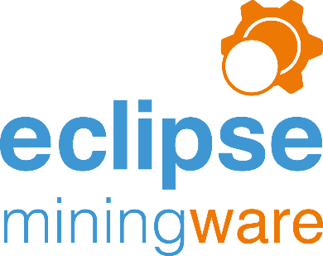

Summary
- Quick to set-up and implement
- Based on modules that have been tested in the field
- Excellent ongoing support & maintenance
- Also available - external consultancy to help get the best value from the system
- Suitable for smaller and medium sized mines, and start up mines
- Built using standard Microsoft technologies
- Enables your engineers to maintain control
- Dove-tails in with Excel so that your Engineers can easily extract additional data (if required)
- Eclipse has been developed with a focus towards the end-user offering quick, validated data entry and instant reporting to support efficient management of mining production data on a day-to-day basis.
- Administrators can add/edit/delete all aspects of the base data including but not limited to: pits, pit areas, patterns, blasts, plant, factors, materials, material types, targets, reconciled actuals, ore blocks, stockpiles, crews, downtime reasons, working conditions…..
- Administrators can add/edit delete dashboards and other aspects of the reporting.
- User accreditation – pit control, engineers, drill & blast, geology
- Available in different languages
- Help: Slack documentation, Skype, Email, Basecamp
- Historical data can be locked with editing available for senior staff only and audit trails put in place. Daily reports can be saved externally to the database and stored as an auditable snapshot.
- Customisable
- Downtime tracking + engine hours…. Enabling you to report on availability + utilization + productivity + more on plant, plant types, plant models,
- Daily reports stored as Excel docs as a permanent record.
- Exported Excel graphs named and dated with Windows login information and stored in network folder.
- Instantly accessible reports – accessible anywhere
- Data validation – controlled collection of data
  - Accuracy of data
  - Data insight
  - Centralised data – unified system
  - Data Stored locally but accessible from anywhere

Eclipse Miningware Modules
Eclipse has evolved over time and brings together the key functions of the mine. The circles represent the relationship between the modules and the proportion of functionality each.

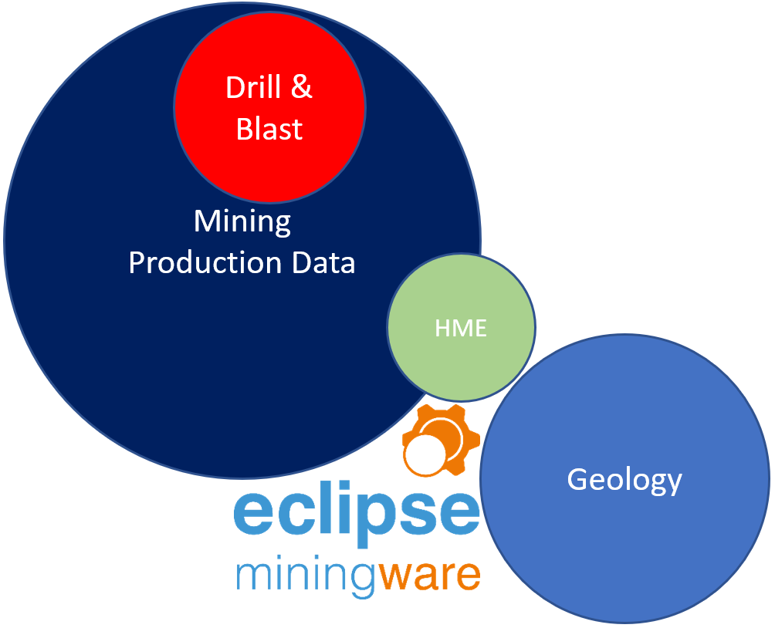

Eclipse Mobile data entry
The basic time tracking PLOD is included in this proposal, but the intention is that the equipment specific PLODs be implemented as soon as possible afterwards.
The aim is to collect as much accurate data as possible electronically instead of relying on the existing paper-based system and subsequent data entry which takes approximately 15 minutes per vehicle. Whilst many of the machines can collect data, it will be the medium term until all of this database is automatically synchronised via the wi-fi network. An excellent medium-term alternative is to use the Eclipse Mobile Plods which will be designed to enable operators to key in data, quickly and easily during their shift. Using the in-built offline storage database on Android browsers, the Eclipse Mobile Plods can store information on the tablet if there is no wi-fi signal and then synchronise when it becomes available again.

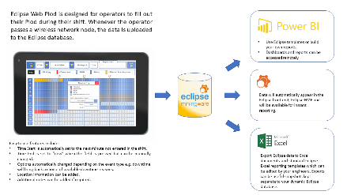
Because data is entered throughout the shift, the total time at the end of the shift will always equal 12 hours instantly improving the quality of data and giving accurate information relating to metrics such as availability, utilization and productivity. Furthermore; if an operator marks a vehicle as “down” then the HME department will be notified on Eclipse HME which automatically updates by the minute.
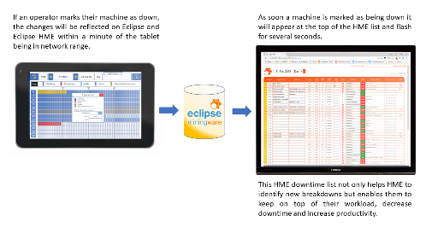

Eclipse Web Plod Synchronisation
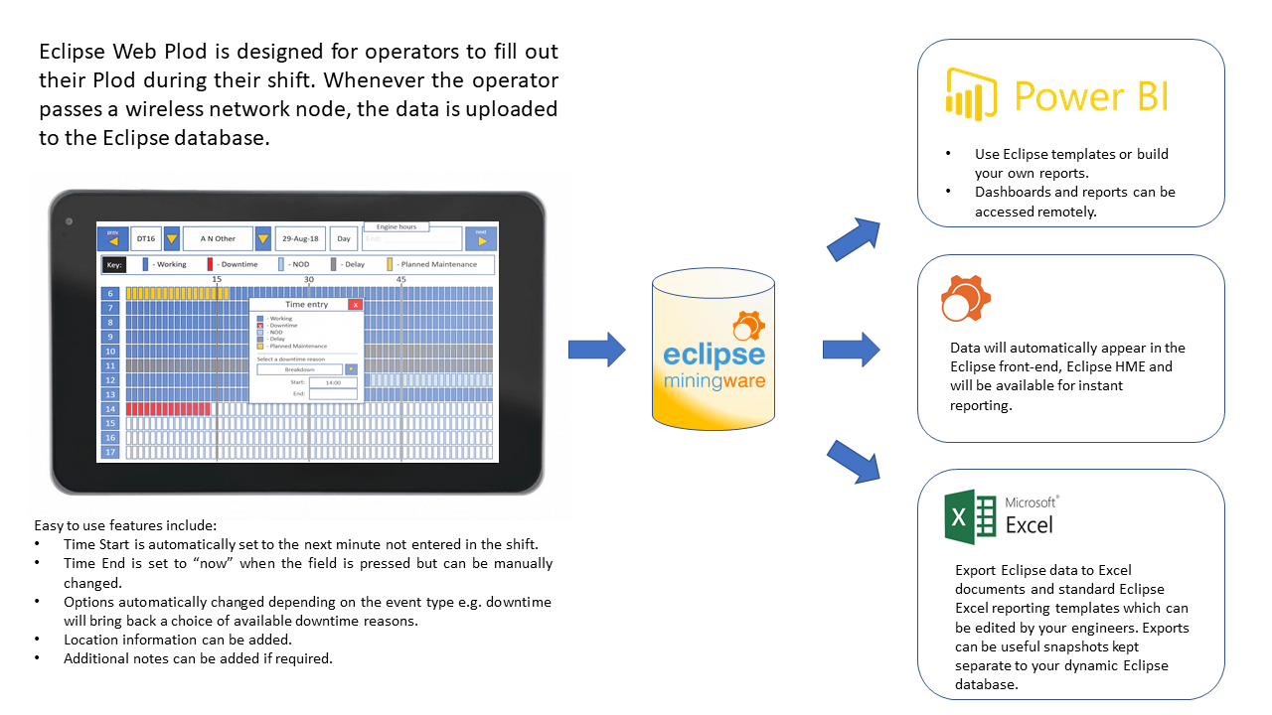

Eclipse Web Plod to HME
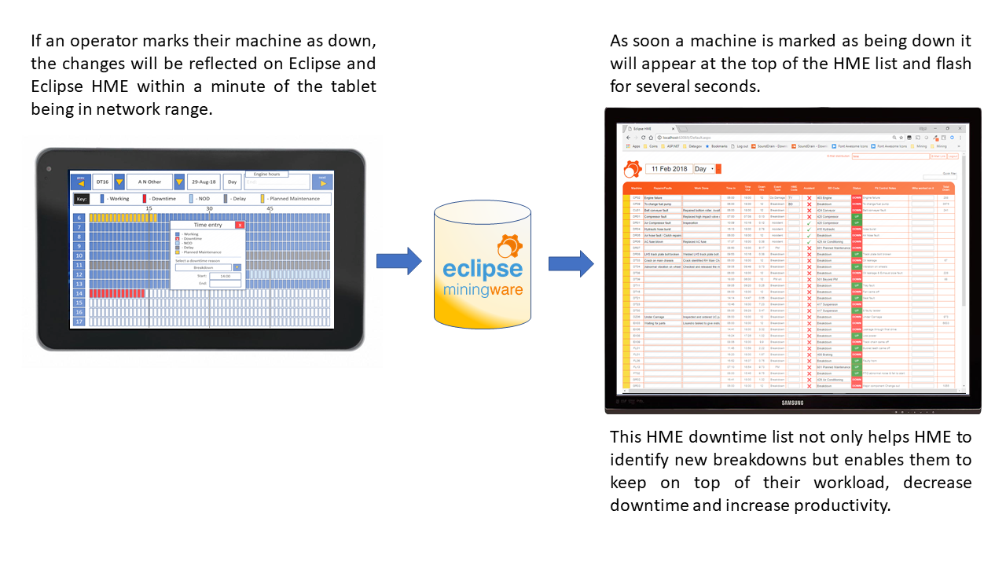

Production
Collecting and maintaining the integrity of your production data, then matching with forecasts are the fundamental foundations of Eclipse Miningware. The production module draws data from the following sections of Eclipse (login areas).
- Pit Control
- Engineers
- Drill & Blast
- Geology

Pit Control
Pit Control data collection and validation: primarily loads and downtime for each vehicle. The granular data refers back to blocks (or phases/pit areas if preferred) which, in turn, relates back to your drill & blast data and targets. Straight forward data entry for Pit Control is helped by
- Drop-downs only displaying materials and classes with factors and densities for the shift.
- Only currently vehicles being available for selection.
- Persistent choices on blocks for primary excavators.
- The location of primary excavators being copied to the next shift.
- Options to copy “downtime” and “non operational delays” to the next shift.
- End engine hours copied to the start engine hours of the next shift (can also be done retrospectively).
- Shift hours checks.
- Checks for multiple operating centers.
- Applying downtime/NODs to multiple plant (“due to tramming” for example) which cross-checks that plant is currently marked as “working”.
- and so on…
Other Pit Control data which can be collected
- Relocation/Rehandle
- Operators – Eclipse stores operator, crew + vehicle as the default values which are then copied to the next shift for that crew
- Operator absence
- Fuel
- Tyre damage
- Exploration/RC drilling

Drill & Blast
The drill & blast section can be locked down so that only certain Windows users can add/update/delete information and more thorough audits exist so that if data is altered, it can be tracked by to a Windows user, date & time.
The Drill & Blast section includes:
- Explosives register
- BH drilling – relating to patterns/blasts/blocks and including drill bits, hammer hours, drilling types.
- Blasting – plans + actual, ability to copy un-blasted holes to a new blast. Once a pattern has been blasted it becomes available to Pit Control for assigning to digging records.
- Consumables register
- Drilling imports for contractor information
- Reporting – daily/weekly/month actual vs targets + costs, blast reports, Excel exports, PowerBI dashboards.

Engineers
Your engineers’ main tasks involve creating the shift reports; validating Pit Control data, filling in any gaps and adding other information that Pit Control may not be able to e.g.
- Water truck loads – including movement “from” and “to”
- Mobile crusher loads – including movement “from” and “to”
- RC/Exploration Drilling
- Importing contractor data
- Cross-checking with Geology (Ore Tally)
- Importing and managing targets: production, productivity, availability and utilization.
Your senior engineers will also be in charge of managing the reference data which is essential for the day to day running of Eclipse including: Pits, Phases, Pit Areas, Blocks, Operators, Downtime Reasons, NOD and Operating Delay Reasons, Material Types and Classes, Plant (including cost/tonne/operating hours/meter), Factors, Densities, Drill Bit Types, Drilling Type Costs (base on m + m/hr), Working Conditions and so on.
Once the data is entered and validated, it’s possible to extract, report on and analyse the data in a multitude of ways including:
- MS Office Reports – with the possibility of emailing as MS Office documents, PDFs and more.
- Reporting and filtering screens within Eclipse which can have filters setup and saved against users for future querying. Filtered data can also be exported to Microsoft Excel which replicates column information.
- Microsoft Excel exports – standard shift reports, to predefined templates or as straight exports.
- PowerBI dashboards – using the Eclipse Data Gateway to link with dashboards which are accessible from computers or mobile devices anywhere in the World.

Geology
Record movement of material from within your mine: Production (Ore Tally using Geology spotters and reconciled with Pit Control at the end of shift), re-handle, relocation, reclaim and crushing information.
- Enables target grades, volume and tonnage to be assigned to ore blocks
- Keeps a running total of production against ore blocks.
- Recalculates stockpile balances on a daily basis based on production, re-handle, relocation, reclaim and what’s been moved to the crusher. Stockpile tonnage, densities and grades can be manually edited to create new starting positions for each day.
- All sections (Production, Rehandle/Relocation and Reclaim) can be “Direct Tip” or load into trucks. This has an impact on the “cost centers” which Pit Control/Engineers may have to address e.g. if a truck works in production/rehandle and reclaim in a shift it will be necessary to split the operating hours accordingly.
- Factors are shared with Mining for consistency.
- Bucket factors and densities can be edited by material type + class + date ranges.
Geology can manage and setup all of their own information including; ore blocks, ROM fingers, stockpiles, crushers, spotters,
Reporting:
- MS Office Reports – with the possibility of emailing as MS Office documents, PDFs and more.
- Query lists and filters in Eclipse which include exports to Microsoft Excel.

HME
Does your HME department know instantly when equipment fails, or do they have to wait for the end of the shift report before leaping into action….? Just one of the many immediate benefits of implementing an integrated tracking process.
If downtime data is entered directly onto Eclipse then the HME department get updated immediately with their own web front-end. This simple front-end helps keep track of all downtime for each shift and helps preserve the integrity of your data. The HME front-end has been designed to be displayed on big screens so that staff have a live feed of vehicle status but works well on PCs and tablets too.
- Locally installed website (Eclipse Web)
- Updates as the database updates - when Pit Control enters data or operators enter data into their tablet Plod, newly downed plant will appear at the top of the list and flash for several seconds to notify staff of the change.
- Downtime and NODs can be copied from shift to shift by Pit Control or an engineer.
- Running total of downtime.
- Live availability and utilization constantly displayed and compared with targets.

Collaboration

IT infrastructure requirements

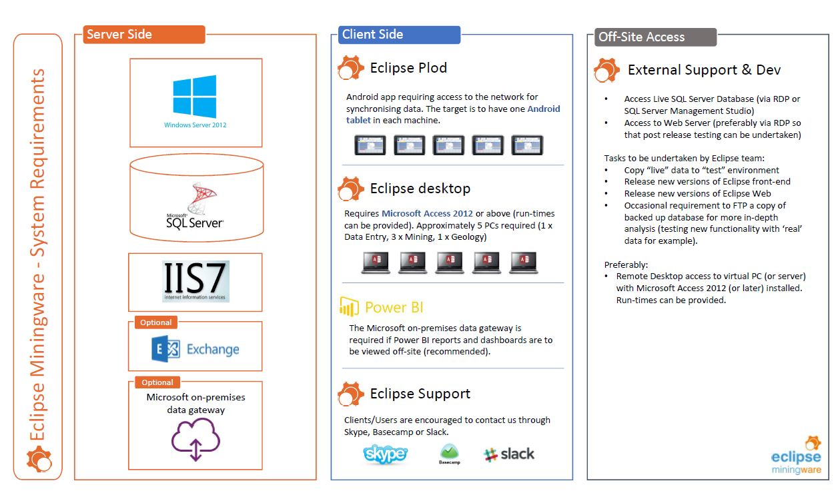

Off-Site Training and Documentation
Key personnel will be able to book “Live” training/’question & answer’ sessions and we will encourage questions by Skype, email or Basecamp which will also form part of the documentation.

Project Management
Areas requiring project management include:
- Liaising with IT and ensuring that the relevant software is installed, permissions set (network and software etcetera), and PCs are made available.
- Co-ordination prior to visit to ensure that all necessary staff are available for training, that all existing reporting sheets are available for comparison and that set-up data such as Budgets, forecasts and ytd data are available in advance.
- Involve staff from the relevant sections (Pit Control, Geology, Mining Planning, Drill & Blast) and identify their needs as well as availability for training, building specifications and testing as well as their leave/holiday schedules.

Licensing
The license will be charged at a cost of $30,000 for each Mine which includes free optional updates for the first year. No part of the software can be used in any other mine without TheDevTeam’s permission. TheDevTeam retain the copyright of the source code. All intellectual property rights relating to the method by which facilities are delivered, remain the property of TheDevTeam and may not be sold or given away without TheDevTeam’s express written permission.

6 Monthly Review
One of our team with work with you on a bi-annual basis to help fine tune your database and work with you to get insights into your data.

On-going Support and Development
We encourage our users to contact us whenever they have a support query or need help in getting the most out of Eclipse.
We successfully provide remote support and development for a number of companies using; Eclipse Slack (knowledge base), Skype (preferred), Basecamp (our project management tool onto which all work and hours will be recorded), Email and telephone.
As a first step we encourage users to search the Eclipse Slack which will have all of the Mine specific information such as your own Eclipse user documentation through to this proposal (viewer restricted). Each new development requiring documentation will have that documentation uploaded to the Eclipse Slack providing an audit trail and comprehensive knowledge base.
We would encourage all users to communicate with us, no matter how small their query seems to be, so that we can deal with any issues before they become problems.
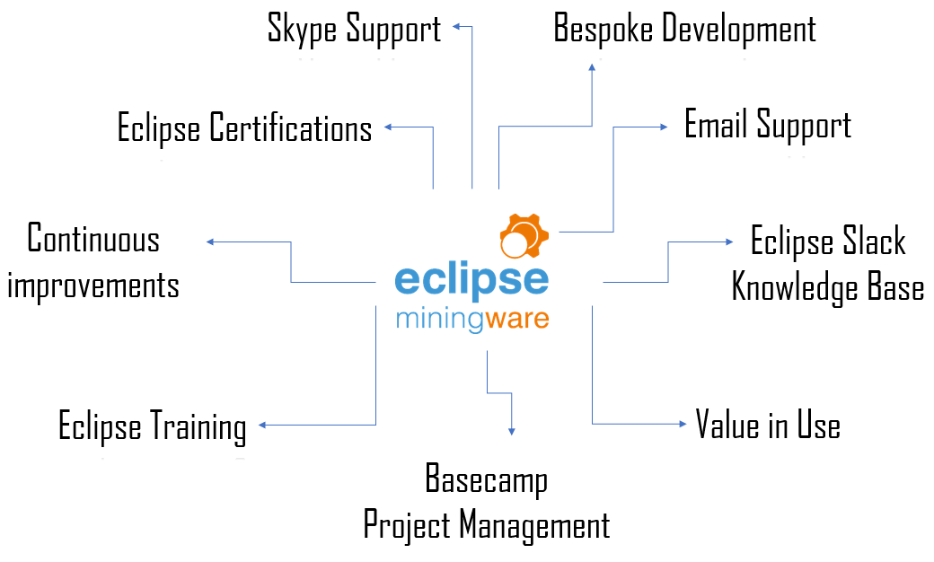

Deployment Plan
A detailed deployment plan will be created at the start of the project.
Nigel will visit the site for 14 working days. During this time he will implement the Eclipse software onto the local network, introduce all relevant staff to the data entry requirements of their section, and work with management to get acceptance of the reporting.
TheDevTeam work on an Agile development basis which means that changes to the specification throughout the life of the project are likely and consequently, so are the priorities.

